1. Open the IIS Manager
2. Right click the Site tab
3. Click add website

* Enter a site Name

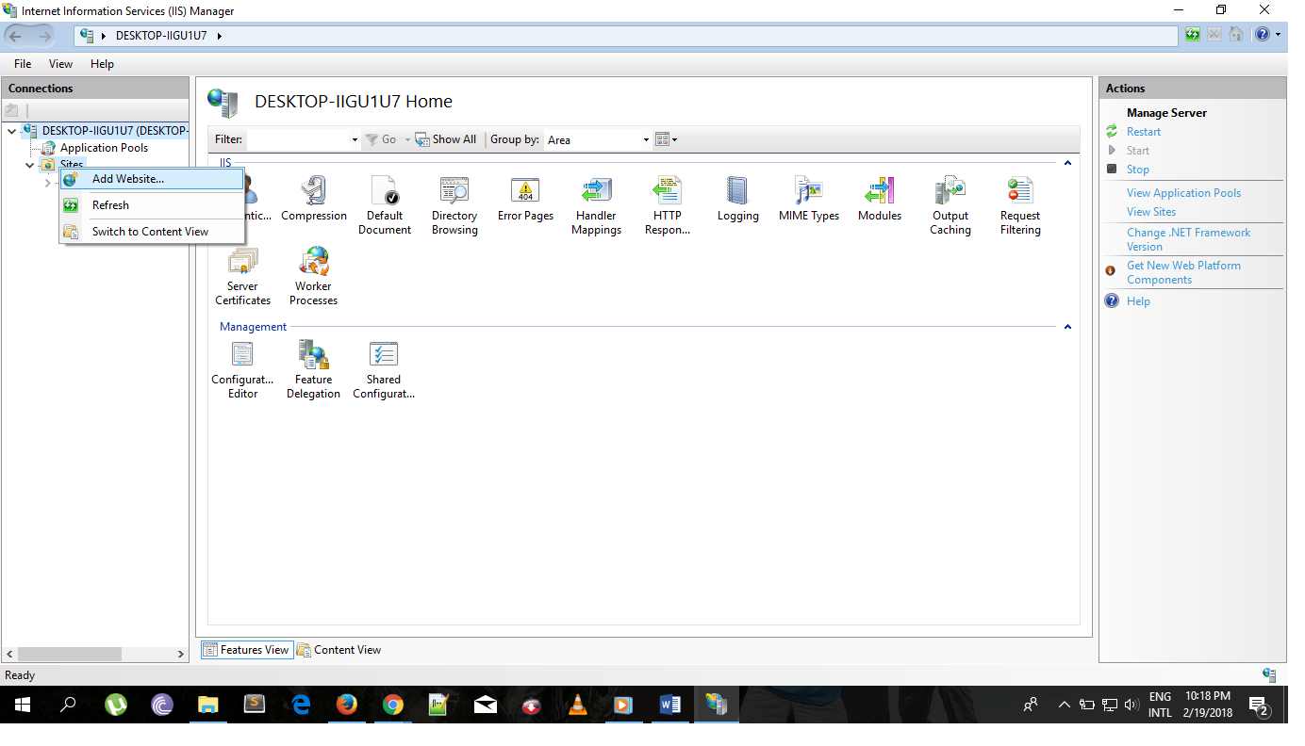

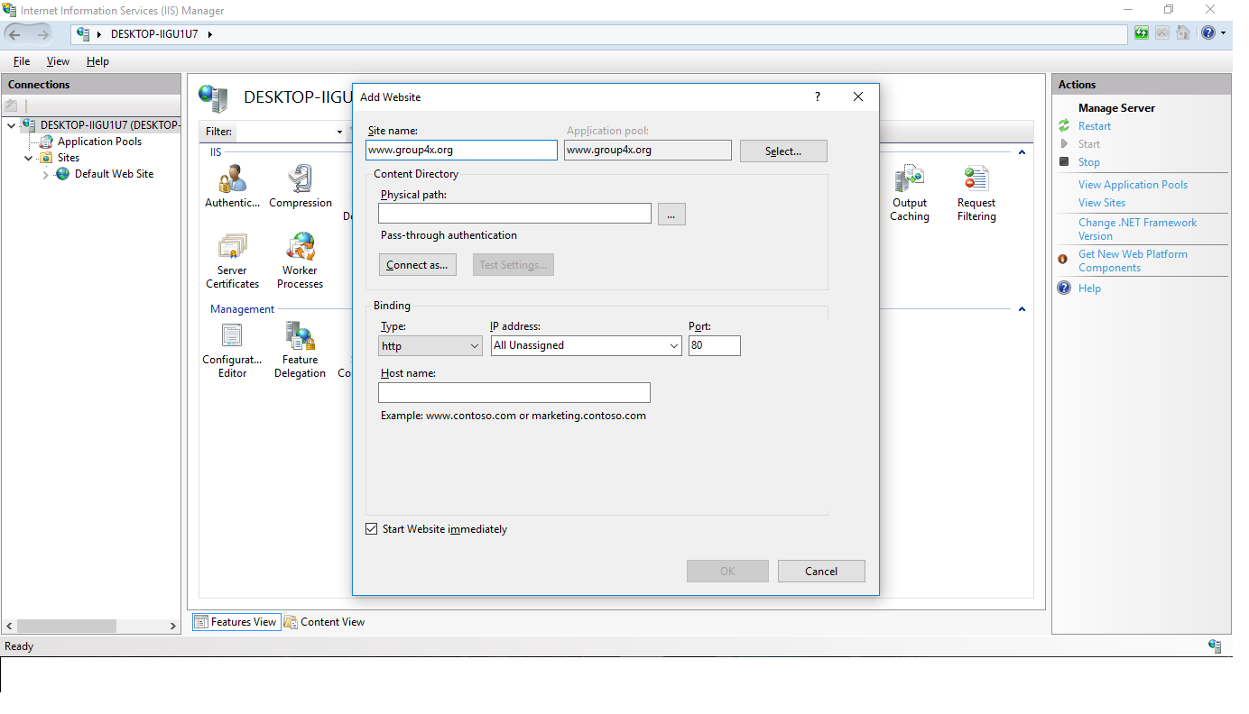

Physical path

* Click the button
* Find where you want to put the files (C:\inetpub)
* And create a new folder and named it group4x.org

Binding

* Don’t change the IP Address and the port number

Hostname

* 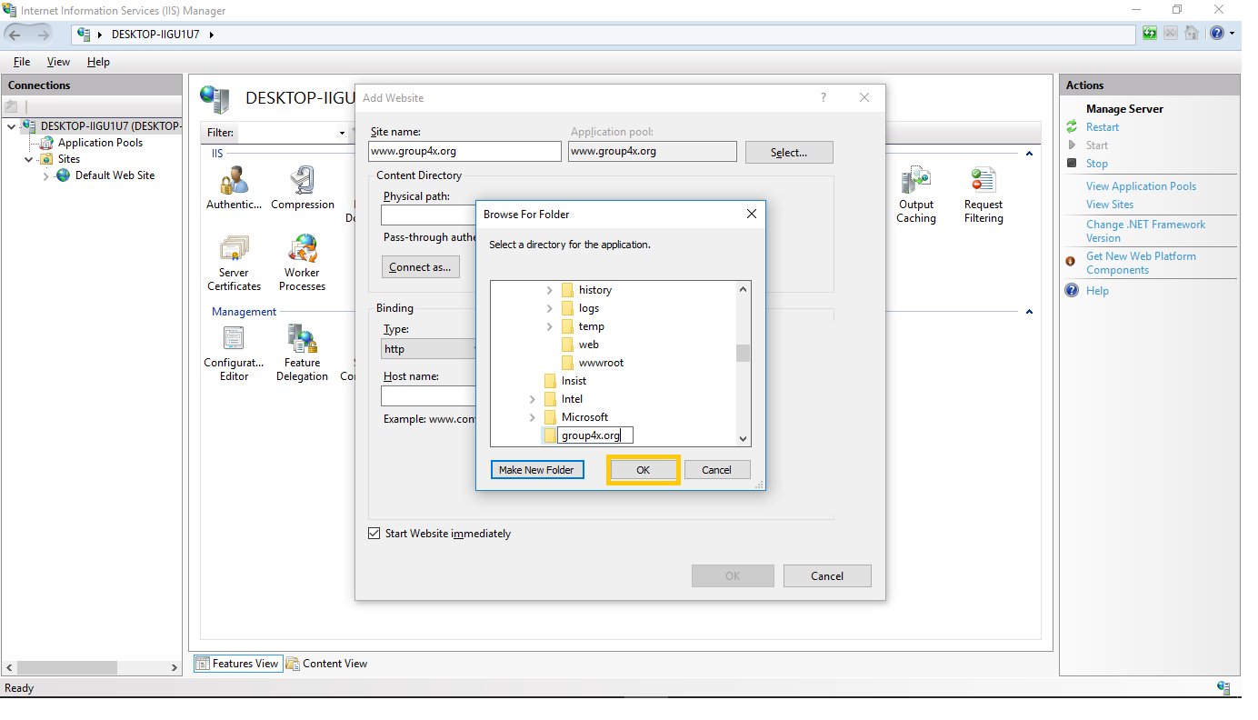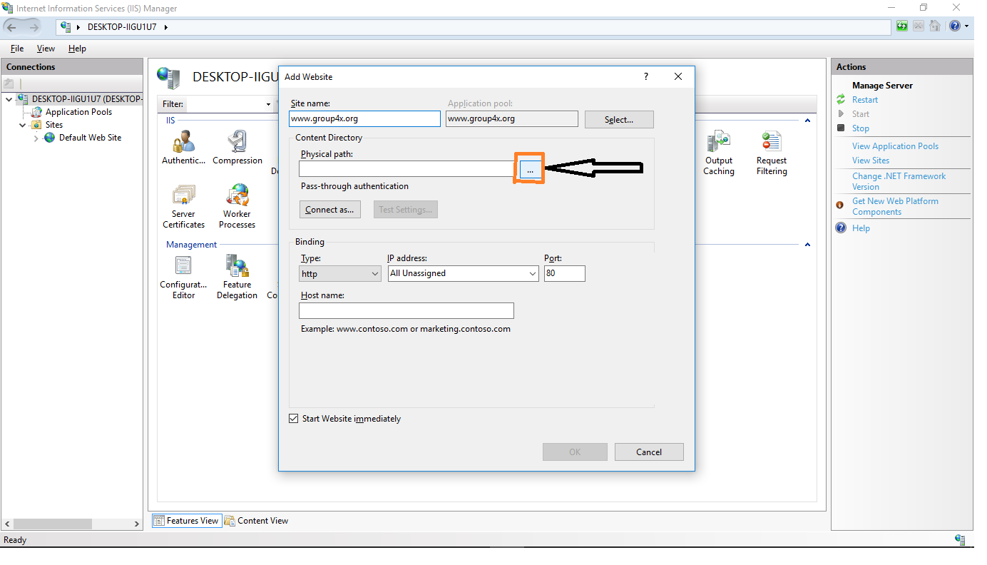Enter the host name the same as the Site name or you can put any name you want

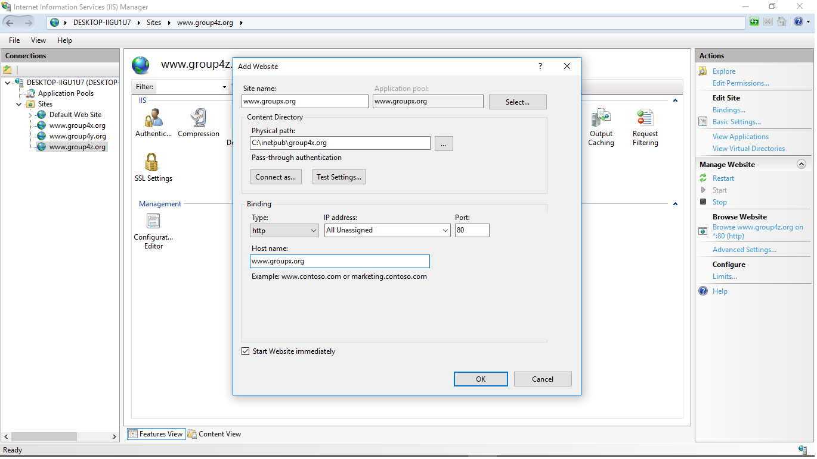

Then click the OK button

* Repeat the steps in adding a new websites (group4z.org and group4z.org)

In each folder of the Hostname place the Html file

* Right click the website then click explore

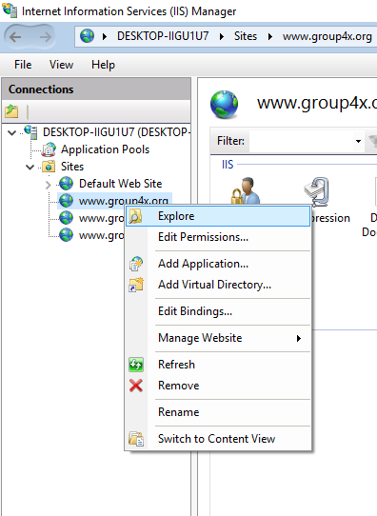

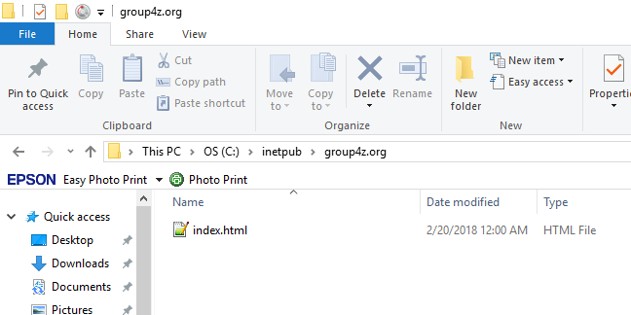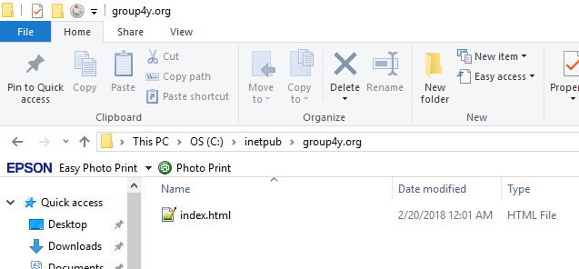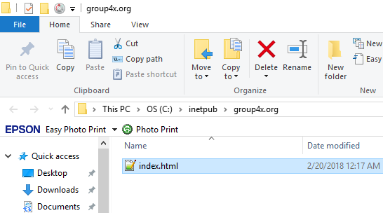

* GO to C:\Windows\System32\drivers\etc
* Open the Host file
* 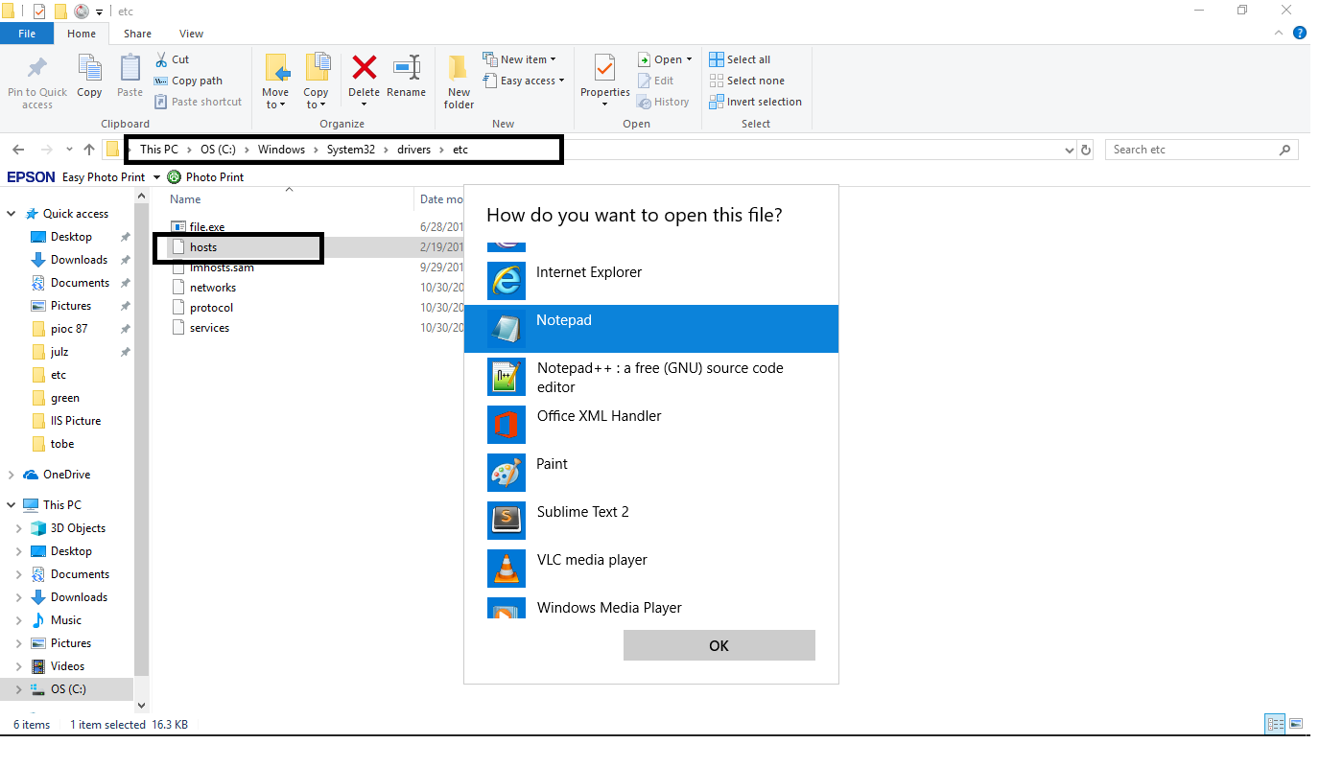To reflect the names of the website we set up in the IIS
* 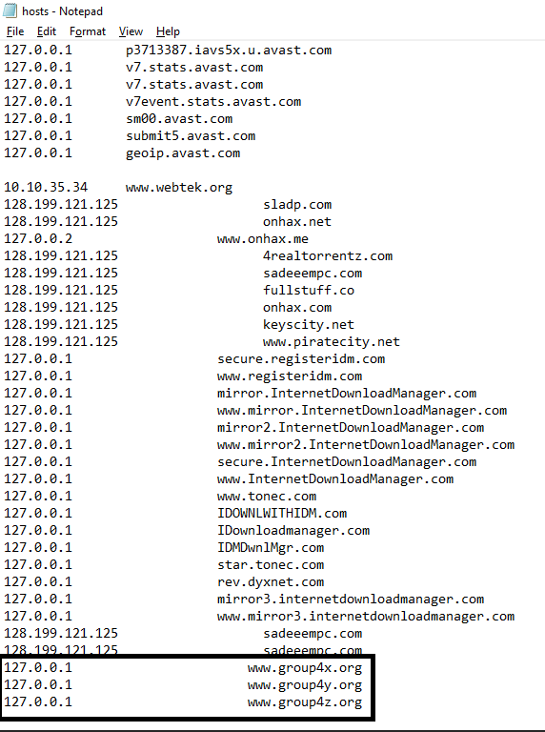then save it

Check your web site

* GO back to the IIS manager
* At the right side click the browser website
* 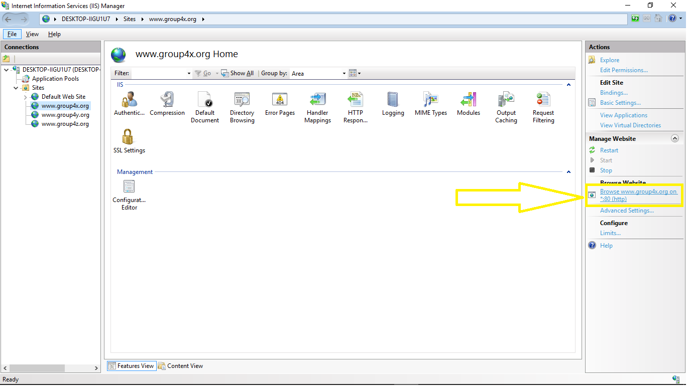And tab will pop out

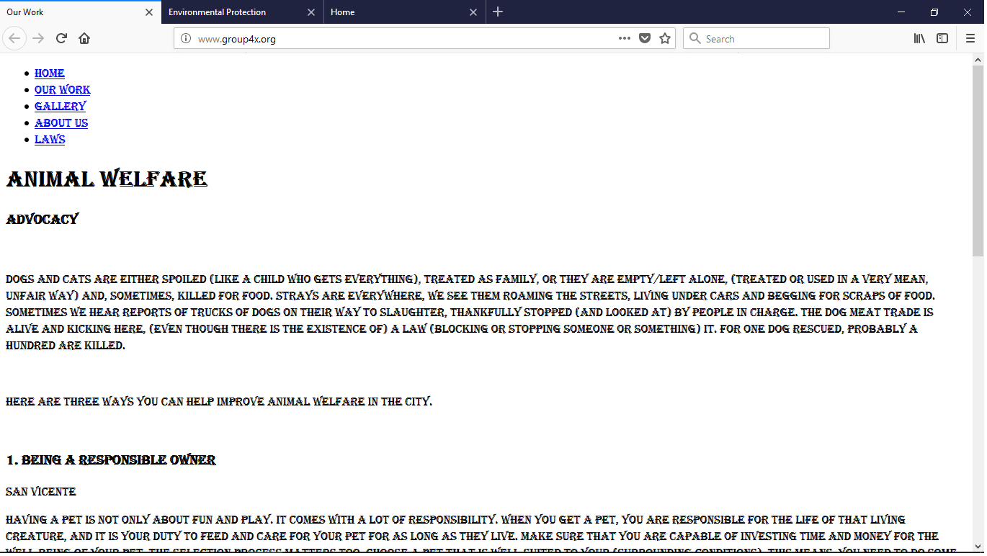Group4x.org

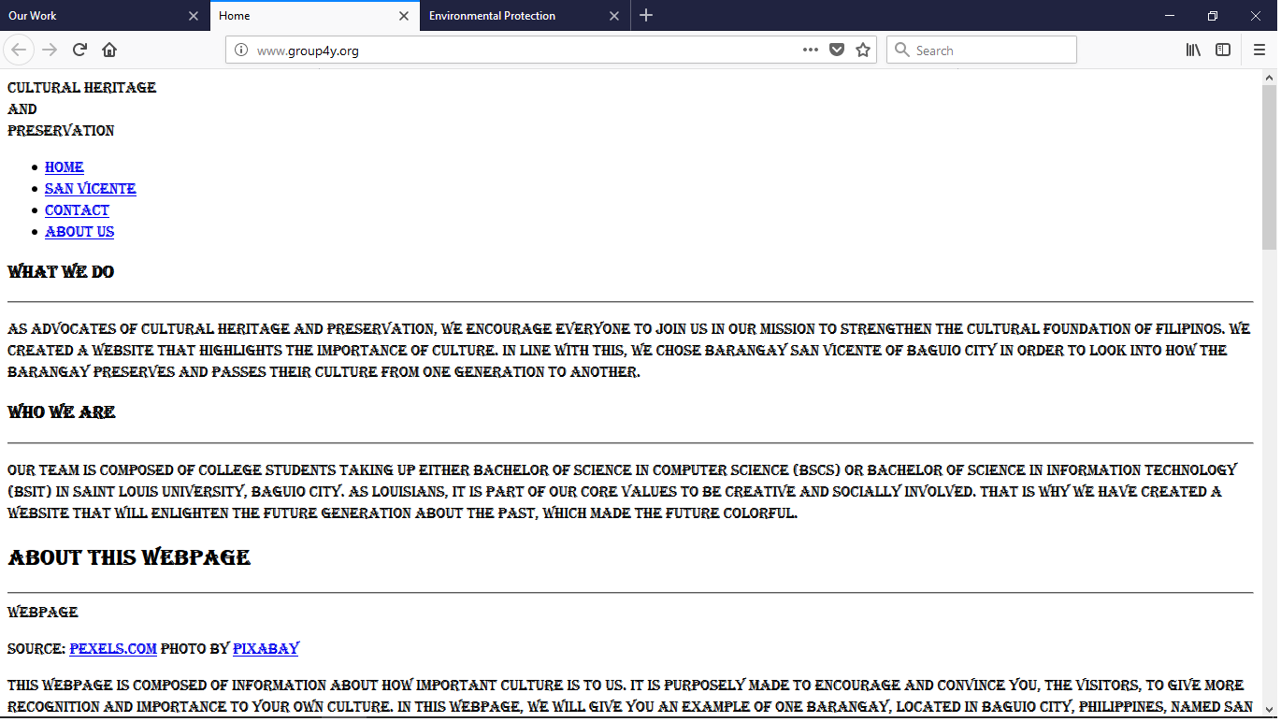group4y.org

group4z.org